

Load DynamiX

FC Series Model 6000 and 6100

Quick Start Guide

Support

Open support cases by sending an email to: support@loaddynamix.com

Table of Contents

Hardware
- What ships with the Load DynamiX product – a list of the contents of the Load DynamiX product.
- Hardware Installation – how to install the Load DynamiX Appliance hardware.
- Admin Network, Date and Time Configuration – how to configure the IP address and Date /Time on the Load DynamiX FC Series Model 6000 and 6100 Appliances.
Software Installation and Project Test
- GUI Software Installation – workstation software requirements, how to install the Load DynamiX TDE and configure the environment for optimum TDE-to-Appliance communications.
- Licensing – how to request and install the Protocol licenses on an Appliance.
- Initial System Configuration – configure and run a test Project to validate that the workstation, appliance and admin network are working correctly.
Troubleshooting, Automation and Other Topics
- Running Load DynamiX Projects – things to consider in preparation for running a Load DynamiX Project.
- Information Typically Required to Design a Load DynamiX Project – a detailed list of information that may be needed when implementing a Load DynamiX Project.
- Load DynamiX Automation – software requirements for using Load DynamiX Automation on a Linux system.
- Appliance Admin User Interface – screen shots of the admin interface for the Load DynamiX Appliance.
- Troubleshooting Tips – product installation and project execution failure troubleshooting information.

NOTE: Microsoft .NETv3.5.1 is required on the Management Workstation (see section D)

SwiftTest recently changed its name to Load DynamiX. Re-branding of our products by our product team is currently in-progress. Until release of the newly branded products, we are providing this documentation containing the SwiftTest name, consistent with the products currently generally available to our customers and prospects.

A) What ships with a Load DynamiX product

- Appliance (one of the below)
- FC Series Model 6000 with two 8Gbps Fibre Channel Test Ports
- FC Series Model 6100 with two 8Gbps Fibre Channel Test Ports
- Load DynamiX USB thumb drive (including a PDF version of this document)
- Hard copy of this document
- Rack mounting hardware (rails, etc)

B) Hardware Installation

Dimensions: Height 3.5”, Width 17.2”, Depth 25.5”

Installation into a Rack
The Load DynamiX FC Series Model 6000 and 6100 Appliance shipping carton includes two sets of rail assemblies, two rail mounting brackets and the mounting screws required to install the system into a rack.

Temperature Considerations: Airflow on the Load DynamiX FC Series Model 6000 and 6100 Appliances is from front to back. The front of the Appliance has the Reset and Power buttons, and the Admin and Test ports. The Front of the Load DynamiX Appliance must be installed on the cool side of the rack in which it is located. Installing the Load DynamiX Appliance with the back of the Appliance on the cool side of the rack can result in chassis overheating and product failure.

Optional: The shipping carton also includes two extension rails that can be attached to the Load DynamiX FC Series Model 6000 to allow it to be serviced without removing it entirely from the rack. These extension rails are not necessary for normal function of the device.

Providing Power
Plug the 2 power cords from the power supply units into a high-quality power source that provides protection from electrical noise and power surges. An uninterruptible power supply (UPS) is recommended. Dual drop circuits for the power supplies is also recommended. Both power supplies must be plugged in for proper function.

Network Cabling
The Fibre Channel test ports on the Load DynamiX FC Series Model 6000 Appliance contain modular SFP+ transceivers. The SFP+ transceiver uses an 850nm laser that requires a Multi-Mode Fiber cable with an LC connector.

Communications Considerations
The Load DynamiX Appliance and TDE together create a test development and execution environment for performance, capacity and stress oriented networked storage tests. It is advisable to have high speed, low latency communications between the TDE and the Appliance to facilitate test development and results gathering and between the Appliance and the device being tested to facilitate test execution.

If the network link between the TDE and Appliance is not high speed or has high latency, it is suggested that the TDE be installed on a Windows VM near the Appliance and the TDE be accessed via Remote Desktop or some other remote access solution. To optimize Appliance to device under test communications, it is recommended that as little network infrastructure as possible be between the Appliance's test ports and the device under test. Network infrastructure can add unexpected delay and complexity during test execution.

C) Admin Network, Time and Date Configuration

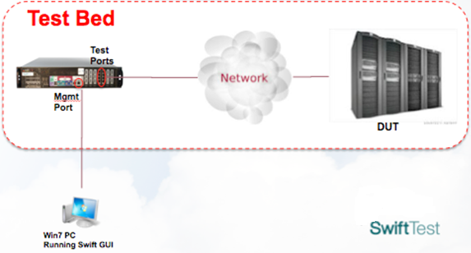
The Load DynamiX FC Series Model 6000 and 6100 Appliances have two types of ports - Admin (1000BASE-T Ethernet) and Test Ports (8Gbps Fibre Channel ports). The Test Ports are configured from the Load DynamiX TDE (the GUI).

Load DynamiX FC Series Model 6000 and 6100 Appliances

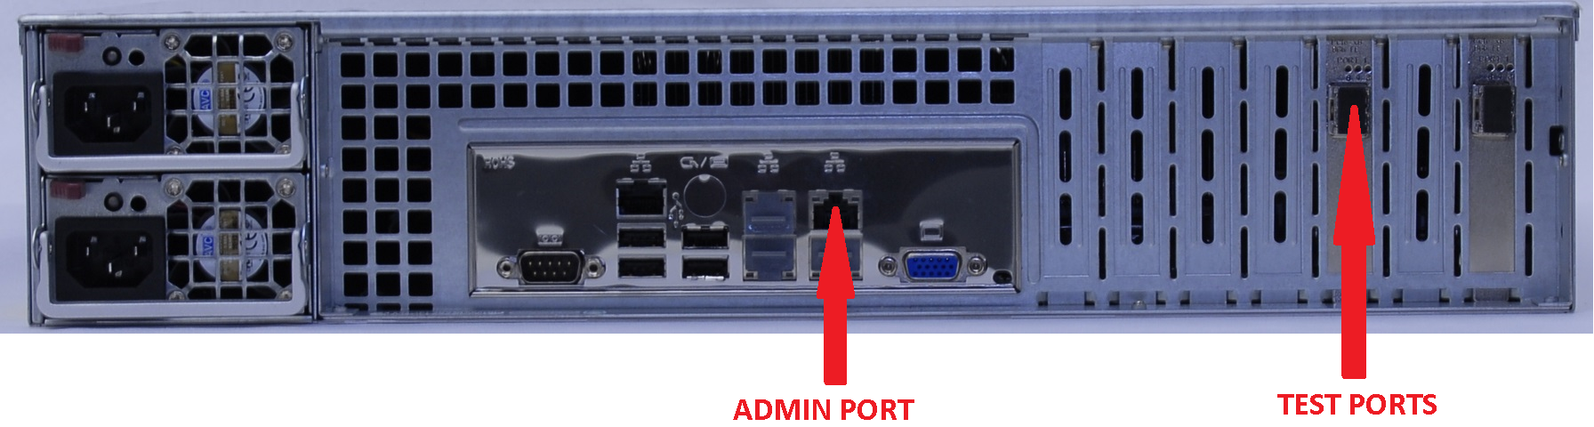

- Connect an 1000BASE-T Ethernet cable to the Admin Port. Connect that cable to a network accessible by the computer on which the Load DynamiX TDE is to be installed (the Load DynamiX WorkStation). This is the ADMIN NETWORK.

- Connect an 850nm Multi-mode Fiber cable with LC connector to the Physical FC Port (see Section B above for cable requirements) 0 or 1 (top left and top right Test Ports) to a Target Fibre Channel switch or DUT. Make sure that the Load DynamiX FC Initiator has been given permission to read and write to the desired target. The WWPN of the Load DynamiX Appliance FC Initiator can be found in the Ports & Appliances window, Appliances Tab. The Target devices that are accessible by this port are shown at the lower right hand part of this window under Targets.

- If the Admin Port IP address (Management IP address), subnet mask and default gateway have been pre-configured for you by Load DynamiX, go to Step 9.

- Connect a keyboard to a USB port or keyboard port and a monitor to the DB15 video port. Alternatively, connect a DB9 serial cable between the Appliance serial port and a terminal or PC. Settings for the serial port are 9600 Baud, 8 Data bits, 1 Stop bit, No Parity and No Flow Control.

- Log in to the admin interface on the Appliance (see section J) Appliance Admin User Interface below for the details of the Appliance Admin User Interface):
User Name: config
Password: config

- Change the network configuration to be on a network accessible by the Management Workstation. Select 1 Network settings and follow the configuration prompts to change the IP address, netmask, and default gateway address. This process sets the Management IP address which will be used by the Load DynamiX TDE to interact with this Appliance. The Appliance admin interface and port do support DHCP. Unless specified by the customer, DHCP is the default for the IP address setting. However, unless the DHCP server is configured to give the Appliance a static IP address, it is not recommended that DHCP be used. See section J) below for details of the user interface for setting the Network settings.

- Confirm the Date and Time configuration is set to the local timezone. Select 2 Date/Time settings and follow the prompts to view the current the date and time settings to confirm that they are correct for the local timezone date and time. If the date and time are not correct for the local timezone date and time, set them according to local time. See section J) below for details of the user interface for setting the Date and Time..

- Log out from the console and disconnect the cables.

- To check your setup, ping the Management IP address of the Load DynamiX Appliance from the Management WorkStation.

  - Open a browser on the WorkStation and type the Appliance IP Address into the address bar and hit return. The text “SwiftTest” should appear in the browser window..

  - If a. fails, Ping the Load DynamiX Appliance Management IP address (C:\Windows\System32\ping <IP Address>).

  - If the Ping is unsuccessful run the Trace Route command (C:\Windows\System32\tracert <IP Address>) to see where the routing process fails then go back to step 4 and verify the IP address, netmask and gateway address assigned to the Appliance. If these are correct, ensure that the Load DynamiX WorkStation is connected to a network that can access the network that the Admin Port is connected to.

D) GUI Software Installation

Management WorkStation Hardware Requirements
- Windows PC, 2 Gigahertz processor clock speed or higher
- 2 Gigabytes (GB) of RAM or higher
- 500 Megabytes (MB) of available hard disk space or higher

Software Requirements

- Windows Vista or 7 operating system, Installation Folders:
    - Windows 7 plus .NET framework version 3.5.1
      - Program executables: C:\Program Files\SwiftTest\{InstallationFolder}
      - Program data: C:\Program Data\SwiftTest\{InstallationFolder}
      - Projects: C:\Users\{UserLoginName}\Documents\SwiftTest\My Projects
      - Resources: C:\Users\{UserLoginName}\Documents\SwiftTest\My Resources
      - User Guides and Documents: C:\Program Data\SwiftTest\{InstallationFolder}\SwiftTest Docs
      - Scripts: C:\Program Data\SwiftTest\{InstallationFolder}\SwiftTest Docs\scripts
      - Mono: C:\Program Data\SwiftTest\{InstallationFolder}\Mono
    - Windows Vista plus .NET framework version 3.5.1
      - Program executables: C:\Program Files\SwiftTest\{InstallationFolder}
      - Program data: C:\Program Data\SwiftTest\{InstallationFolder}
      - Projects: C:\Users\{UserLoginName}\Documents\SwiftTest\My Projects
      - Resources: C:\Users\{UserLoginName}\Documents\SwiftTest\My Resources
      - User Guides and Documents: C:\Program Data\SwiftTest\{InstallationFolder}\SwiftTest Docs
      - Scripts: C:\Program Data\SwiftTest\{InstallationFolder}\SwiftTest Docs\scripts\
      - Mono: C:\Program Data\SwiftTest\{InstallationFolder}\Mono
    - Windows XP, Server 2003, Server 2008 plus .NET framework version 3.5.1
(Windows XP SP3 support: SwiftTest will support XP-related problems if the problem is repeatable on Windows Vista or Windows 7)
      - Program executables: C:\Program Files\SwiftTest\{InstallationFolder}
      - Program data: C:\Documents and Settings\All Users\Application Data\SwiftTest\{InstallationFolder}
      - Projects: C:\Documents and Settings\{UserLoginName}\SwiftTest\My Projects
      - Resources: C:\Documents and Settings\{UserLoginName}\SwiftTest\My Resources
      - User Guides and Documents: C:\Documents and Settings\All Users\Application Data\SwiftTest\{InstallationFolder}\SwiftTest Docs
      - Scripts: C:\Documents and Settings\All Users\Application Data\SwiftTest\{InstallationFolder}\SwiftTest Docs\scripts
      - Mono: C:\Program Files\SwiftTest\{InstallationFolder}\Mono

- Windows .NET version 3.5.1 framework from Microsoft must be installed on the Management Workstation. Windows 8/Server 2012 do not have .NET 3.5.1 enabled.
    - To verify that .NET v3.5.1 is installed on the Management WorkStation, issue the following commands from a command window prompt:
    - dir C:\WINDOWS\Microsoft.NET\Framework\v*
    - dir C:\WINDOWS\Microsoft.NET\Framework64\v*
.NET Framework installations are not cumulative - .NET v4 does not contain v3.5.1.

To install .NET Framework on Windows 7 or earlier releases:
    - If not, if the Management WorkStation has access to the Internet, download the .NET 3.5.1 bootstrap loader at:http://www.microsoft.com/en-us/download/details.aspx?id=21
    - If the Management WorkStation doesn’t have Internet access, using a system that does, go to the URL displayed above, click Instructions, look for the phrase “Full Redistributable Package” follow the instructions to download the full .NET 3.5.1 package, then install it on the Management WorkStation.

To enable .NET v3.5.1 on Windows 8 or Server 2012,
- Open the Control Panel and click the Programs and Features link
- Click the Turn Windows Features on or off link
- If not checked, click the box to the left of Microsoft .NET Framework 3.5.1 and OK
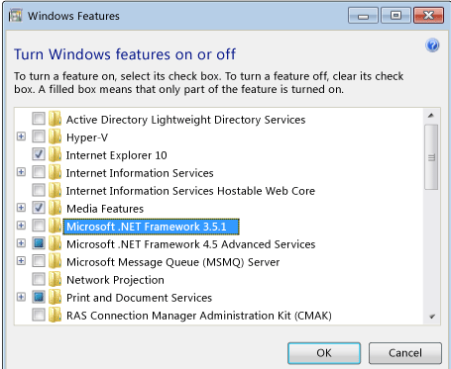

- For Load DynamiX FC Series Model 6000 project execution on a Linux workstation, see Section H).

Management WorkStation to Appliance Communications

The Load DynamiX TDE and Automation tools communicate with Load DynamiX Appliances using the HTTP protocol. For the TDE to function properly, the TDE must be able to send and received HTTP packets with the Appliance. To test communications between WorkStation and Appliance try the following:

- From a browser on the WorkStation, type the Appliance <IP Address> into the address bar and the word SwiftTest should appear in the browser window.
- If #1, does not work: From a command prompt on the WorkStation, Ping the Appliance IP address (Windows command: ping <IP Address>)
- If #2 does not work: From a command prompt on the WorkStation, run a trace route (Windows command: tracert <IP Address>)

If any of the above tests fail, the WorkStation and Appliance will not be able to communicate.

Management WorkStation HTTP Proxy Configuration

If an HTTP proxy has been enabled for the computer running the TDE, be sure to either add the address(es) for the Load DynamiX appliance(s) to the HTTP proxy or disable the proxy setting for the computer running the TDE.

HTTP access. The Load DynamiX TDE and command line Automation both use the HTTP protocol to communicate with the Appliance. If the system running the TDE or Automation cannot communicate with the Appliance via HTTP, no Projects will be executable. A simple test of HTTP access o the Appliance from any system is to open a browser on that system, enter the Appliance's IP address in the browser's address bar. What should be seen is the word SwiftTest in the upper left hand corner of the browser.

Software Installation

- The software is available on a Load DynamiX USB thumb drive or from the Load DynamiX FTP site.
    - If you are downloading the GUI software from the Load DynamiX FTP site, copy the Load DynamiX .ZIP file to your computer.
      - Load DynamiX FTP site: https://loaddynamix.egnyte.com/
      - Uncompress the .RAR file. If you do not have a program to uncompress the file you can download winRAR from rarlabs.com or other RAR sites.
      - Copy the .msi file to your computer.
  - If you have the Load DynamiX thumb drive, insert the disc into the Load DynamiX WorkStation's USB port.

- Double click the icon SwiftTestTDE.msi. Follow the setup instructions.

E) LICENSING

Load DynamiX licenses Appliance on a per-protocol basis. This means that, on a per-Appliance basis, each Protocol that is to be used on that Appliance must be enabled in the license that is associated with that Appliance. An Appliance will NOT execute Projects that contain Protocols for which it is NOT licensed. The TDE itself is not licensed but the TDE is the tool that is used to administer licenses for Appliances. Once an Appliance is Licensed, downgrading to a prior release will not undo Activation or any Licenses installed.

Licensing Process Terminology:

Protocols: The basic unit of licensing. Purchase of the Load DynamiX product requires purchasing the use of various protocols - for example CIFS-SMB, NFSv3, iSCSI possibly Client and Server. Appliances will be licensed for all of the Protocols that a user has purchased.

Temporary Licenses: A Temporary License is a license for one or more Protocols that is valid up to a certain Date. It is useful when evaluating a new Protocol before deciding to purchase the license for that Protocol.

Permanent Licenses: Most licenses are Permanent. When a user purchases an SMB2 Client and Server Protocols, they are purchased permanently and will be licensed as such.

Emergency Licenses: If for some reason an Appliance's License file does not work, the user can create an Emergency License from the License Management window to enable all Protocols for 7 days. Once the Emergency License expires, it is NOT possible to create a new Emergency License until a Temporary or Permanent License has been installed.

Activation: Preparing an Appliance to be licensed. The Activation process installs an Activation Record on the Appliance and enables the Appliance to accept protocol licenses. Activation of Appliances installed in customer facilities is only required for Appliances that were shipped before May 2013. The easiest way to check if an Appliance is ready for licensing is to open the Ports & Appliances Window and select the Appliances Tab.

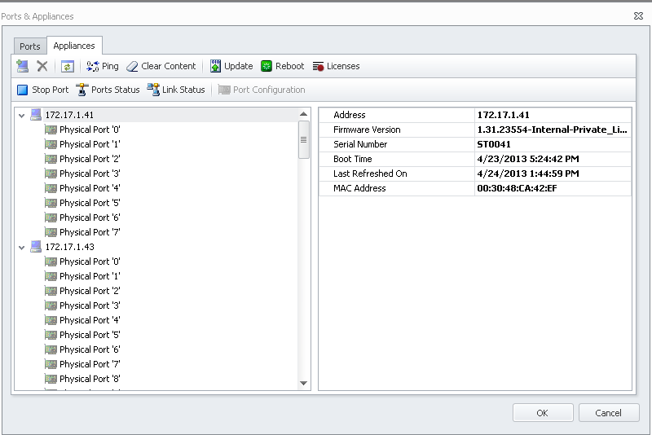
Click the Licenses button and if the following dialog appears, the Appliance is not currently not running the appropriate revision of the Load DynamiX firmware
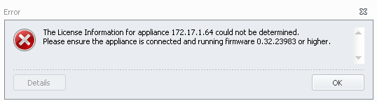

If instead of the error dialog above, the user gets the following message then the Appliance is ready to be Activated. If user does not see the Activation dialog below then the Appliance is already Activated and ready to have Licenses installed.

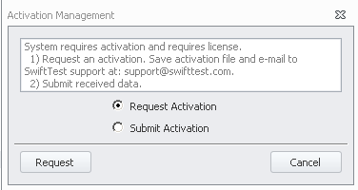
Ready For Licenses: An Appliance is ready for licenses once it has been Activated. Clicking on the License button in the Ports & Appliances > Appliances Tab will open the following License Management window which shows no licenses installed yet. This Appliance will not run any Load DynamiX Projects because none of the Protocols are licensed.
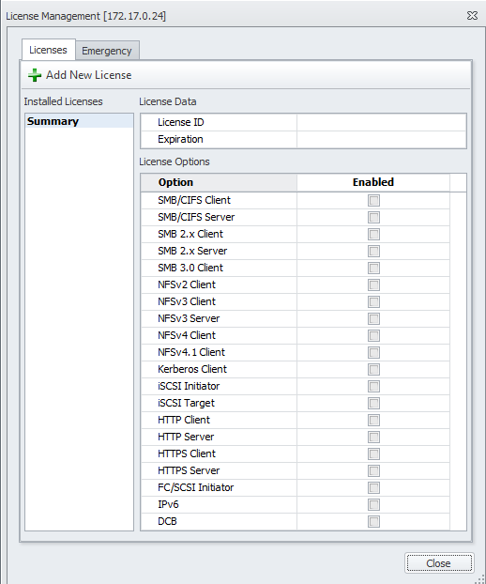

Licensed: When the License Management window shows active licenses then the Appliance is ready to run Projects that contain the licensed Protocols (and ONLY the licensed Protocols). The following License Management window shows active licenses.
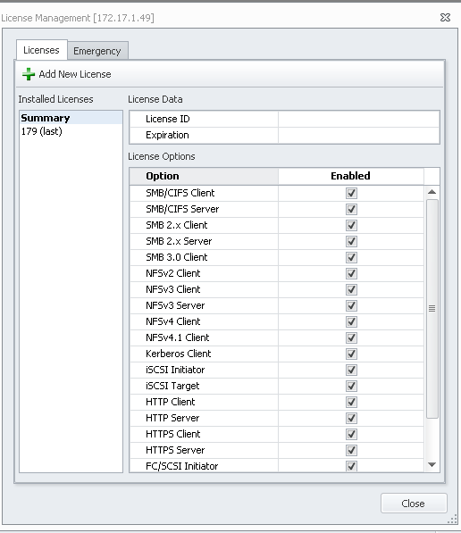

Licensing Process:

This process must be repeated for every Appliance that is to be Licensed.

If an Appliance is Licensed, the set of Protocols which are licensed an Appliance will appear when the Ports & Appliances > Appliances Tab, Licenses button is pressed. Licensed Protocols will be indicated by check marks in the Enabled column as seen here.

If the Appliance is not Activated then open the Ports & Appliances window > Appliances tab. Highlight the Appliance to be Activated and click the Licenses button . When the Activation dialog appears

click the Request Activation radio button and then click . The TDE will open a dialog box which allows the user to save the Activation File on his computer's hard drive. The file will be named <Appliance Mac Address>_request.txt.

This file must be emailed to Load DynamiX Support so that Support can create the Activation Record and License File for this Appliance. Save the file to a folder and then email it as an attachment to Load DynamiX Support. When Load DynamiX Support responds to this email they will provide the user with two files:

Activation Record: <Appliance Mac Address>_<Appliance Serial Number>.activation.txt
License File: <Appliance Serial Number>_license.txt

Save these files to the computer's hard drive.
Click the Licenses button in the Ports & Appliances >Appliance tab with the Appliance to be licensed highlighted and then click the Submit Activation radio button and select the <Appliance Mac Address>_<Appliance Serial Number>.activation.txt file. The TDE will deploy the Activation Record and then immediately open the License Management window.

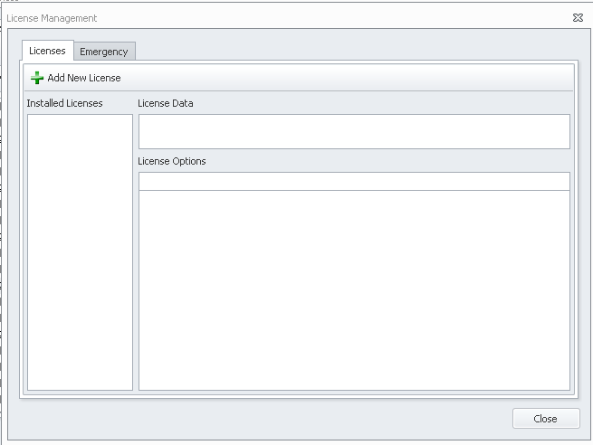

Click the Add New License button and select the License File: <Appliance Serial Number>_license.txt and the contents of the License File will be displayed in the window .
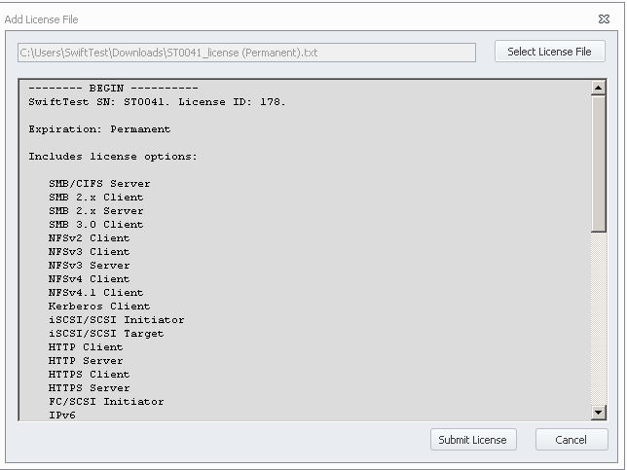
Click 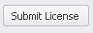 to deploy the License File and the supported Protocols will be displayed on the right side of the window.

The Appliance is now ready to run projects that contain the Protocols that appear on the right side of the window.

Emergency License
If for some reason an Appliance's License file does not work, use the Emergency License.

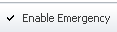
Click the Emergency Tab on the License Management window and then click the Enable Emergency button which will enable all Protocols on this Appliance for 7 days.
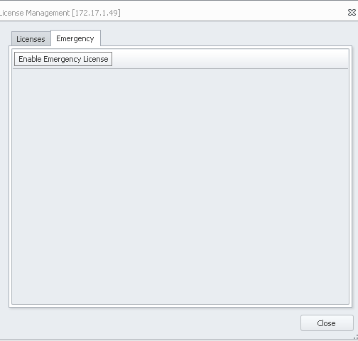

F) Initial System Configuration
- Start the Load DynamiX Test Development Environment (GUI) by double clicking on the icon on your desktop or in the Start menu. Occasionally, on a Windows 7 system, the TDE will not start unless it is Run as Administrator. If after attempting to execute the TDE, an error dialog box saying that the "Load DynamiX TDE has stopped executing" pops up, right click on the TDE icon and select Run as Administrator. This is only required the first time the TDE is executed.

- Click Project Library tab in the lower left corner of the main TDE window.
- Click SwiftTest Projects and open the Block then Fibre Channel folder.
- Double Click the FC Full Duplex Payload project.
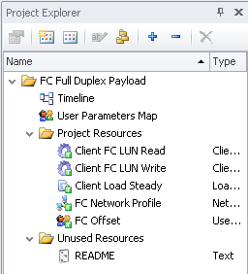

- The sample test is Read-Only. Save a copy in your My Projects directory.

Establish a connection from the TDE to the Appliance:

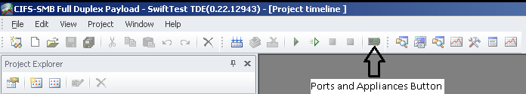
  - Click the Ports & Appliances icon in the upper center portion of the GUI.

  - Select the Appliances tab in the Ports & Appliances window.

  - Click the Add icon at the top of the window.

  - Type the Management IP address of the Appliance and click Add.
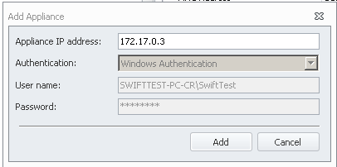
Ensure the Appliance is running the latest software:
  - Click the IP address of the Appliance and click the Update Appliance Firmware icon .
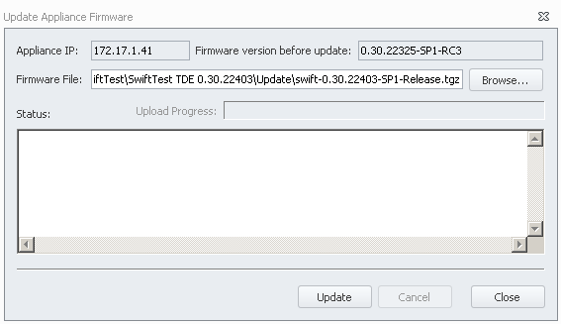
  - Click Update in the Update software window.

  - When the update finishes click Close.

  - Click the Reboot icon. (the next 3 steps are optional)

  - Click Reboot in the Reboot Appliance window.

  - When the reboot finishes, click Close.

- Return to the Ports tab and connect the Appliance Client Port 0 and Server Port 0 to the GUI:

  - Click Ports on the Ports & Appliances window.

  - Drag Physical FC Port '0' or Physical FC Port ‘1 to Client Port 0 (FC Physical Ports cannot be dragged onto Server Ports)

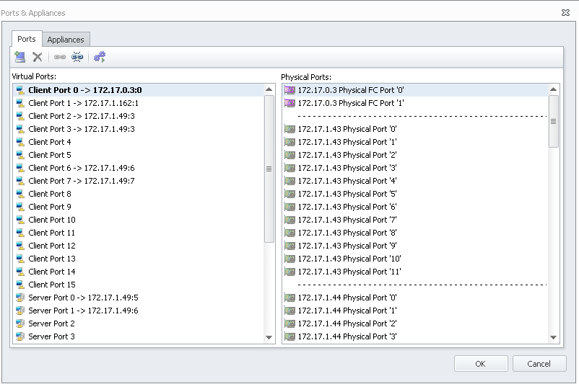

  - Click OK.

Run the Sample Test

- The FC Full Duplex sample test requires that the FC Target address be entered into the Open FC Connection Action. To do this, got the Ports & Appliances window and click the Appliances tab. Highlight the desired port (Port 0 or 1 whichever was dragged onto Client Port 0 above) and copy the desired Target WWPN from the window. Open the Read and Write Scenarios and paste the Target WWPN into the Input of the Open FC Connection Action. Also open the Read Capacity(10) Action in each Scenario and set the correct value for the LUN that is to be read or written. This test will write and read 1MB at LBA 0 in a loop 100 times to the LUN selected. Save the changes to the Scenarios by clicking the OK button at the bottom right.
- After following the steps described above, click the Start Button icon at the top of the main GUI window or press F5 to begin the test.

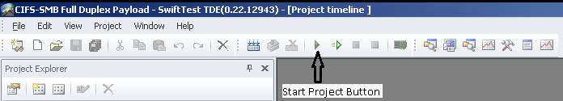

- View statistics during and after the test:
  - Click View->Results Explorer to view test statistics.

  - Expand the Results folder with the current date and time.
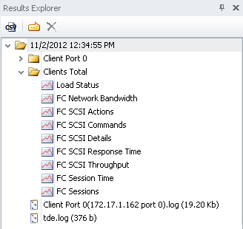

  - Expand Clients Total folder.

  - Double click the FC SCSI Commands report to view the SCSI commands that have executed.

      - If only Read Capacity(10) commands show as successful and FC Sessions show as failed then it is likely that the wrong Target has been used in the FC Open Connection Action or that the connection between the Appliance and Target is bad. Check the Ports and Appliances Window to ensure the correct physical ports and Targets have been selected.

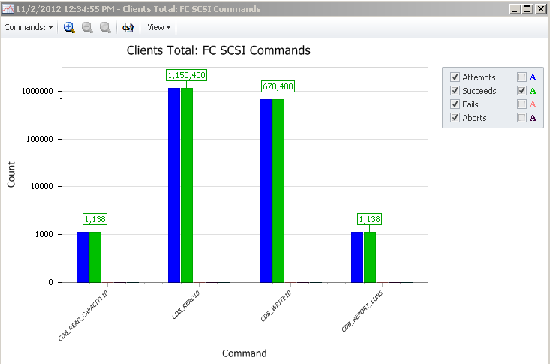

  - If this test is successful (reads and writes successfully sent to the FC Target), the Load DynamiX Test Development Environment and the Load DynamiX Appliance are operating correctly. If you see low/zero commands executed or Fails or Aborts, there is likely a problem.

- Once this test is successful, connect the 850nm Multi-mode Fiber cable with LC connector to the other Physical FC Port (0 or 1 whichever was not used in the initial test run) and rerun the test.

G) Running Load DynamiX Projects

The GUI Software Installation, Initial System Configuration and Run Sample Test steps above ensure that your Load DynamiX TDE is installed correctly, can communicate with your Load DynamiX Appliance and that the Appliance is functioning correctly. To ensure that you are able to move forward with more relevant testing, consider these suggestions.
- Ensure that the Load DynamiX Initiator WWPNs are given the appropriate permissions on the FC Target WWPNs.
- For optimum performance ensure that the Target WWPN and any intervening switches have at least 8Gbps Fibre Channel interfaces.
- Configure any intervening switches to allow the Load DynamiX Initiators to have access to the desired Targets.

H) Information Typically Required to Design a Load DynamiX Project

Some pieces of information that will be helpful to know before beginning to design a Project using the Load DynamiX TDE

Device Under Test Target Address (WWPN): Load DynamiX Projects require a device under test to connect to and that device is specified by its WWPN. If multiple Targets are required be, sure that they are all connected via switches or other mechanisms so as to be accessible from the Load DynamiX Appliance.
Initiators: How many Initiators are required to accomplish the Project objective.
LUN: The FC SCSI Protocol requires specific Logical Unit Numbers for read and/or write operations as well as meta-data commands like Read Capacity(10).
LBA range: The Load DynamiX Project will need to know what the LBA range is for reads and writes.
Size: How many megabytes, terabytes, gigabytes are going to be required for the test. Does the LUN have the capacity that is required?
Load: How much load does the test need to place on the device under test?
Duration: How long should the test run?
Throughput: What throughput (IOPS, kilobytes/sec, etc) is required or desired?

Information Required Decision Matrix

Protocol | Target WWPN | Ports | Dom/Mach Name | Auth | User Names | File-systems | Files | URI | IQN | LUN | Size | Load | Duration | Throughput
FC SCSI | YES | YES | NO | NO | NO | NO | NO | NO | NO | YES | YES | YES | YES | YES

I) Load DynamiX Automation on Linux
For more details on Automation, please see the discussion in the TDE online help:
Appendix: Test Automation.

J) Appliance Admin User Interface

When telneting into a Load DynamiX Appliance, the user is presented with a typical Login prompt for User ID and Password. The only available User ID and Password for the Load DynamiX Appliance are:

User ID == Config
Password == Config

The user interface that appears when logging in as Config/Config is:

Splash Screen
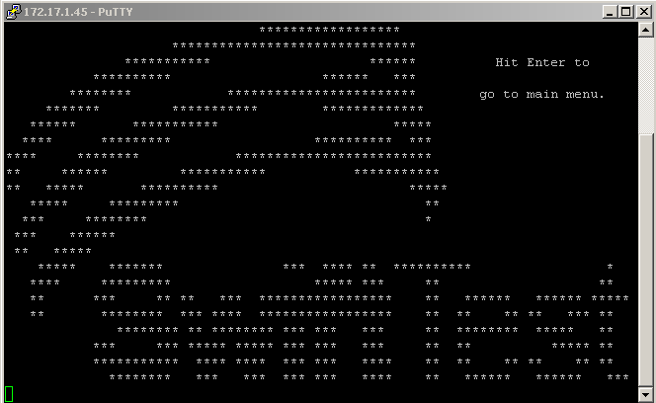

Button Legend for all menus:
< OK > - complete the current selected operation
<Cancel> - Return to the Main Menu (or to splash screen if in Main Menu)
< No > - do not complete the current operation
< Back > - return to the previous screen or menu
<Left/Right Arrow or Tab> - move left or right between buttons
<Up/Down Arrow> - move up or down on Menu items

TO SET APPLIANCE IP ADDRESS
Press the Enter key to get the Main Menu

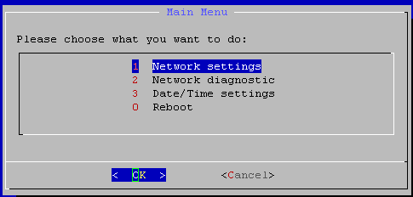
Press the Enter key to change the Appliance's IP Address
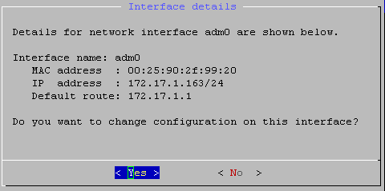
Press the Enter key for < Yes > or <Right Arrow>/Enter for < No >

Select < Yes > to change the IP Address configuration
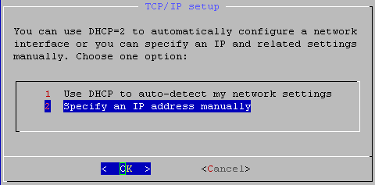
Press the Enter key to get the Specify and IP address manually page (recommended)
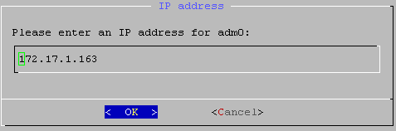
Enter the new IP address into this field and press the Enter key.
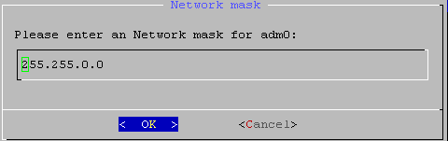
Enter the appropriate (valid and non-empty) Network mask for the Appliance and press the enter key.
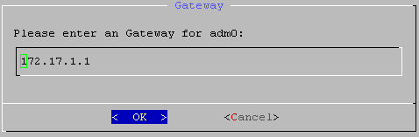
Enter the Gateway router IP address for the Appliance or empty (if there is none) and press the Enter key.

TO SET APPLIANCE TIME and DATE

To set the Date and Time, highlight Date/Time settings on the Main Menu and press the Enter key.
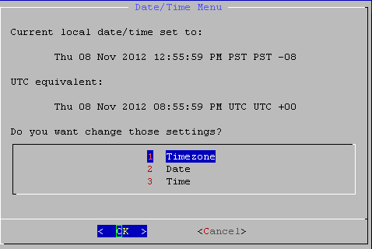
If the Date, Time and Timezone are not correct, press the Enter key to set the Timezone

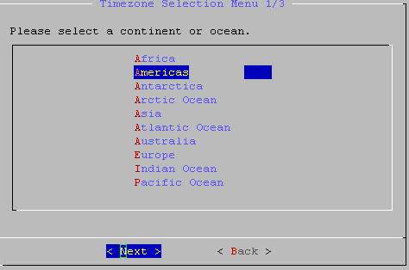
Select the appropriate continent or ocean using the Up or Down Arrows and press the Enter Key for the next page.
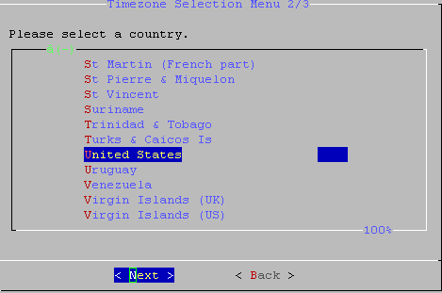
Select the appropriate country and press Enter.
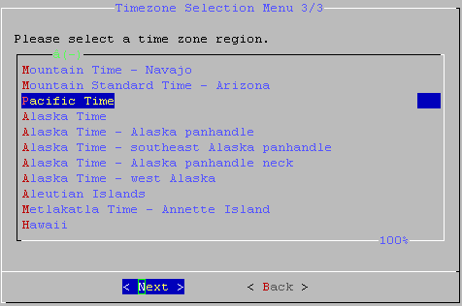
Select the appropriate Timezone and press the Enter key.
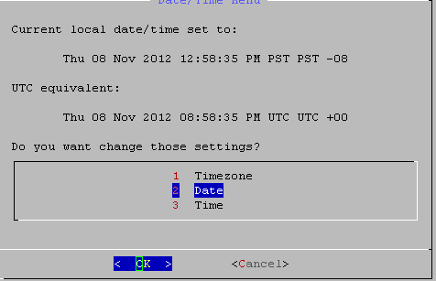
If the Timezone and Time and Date are correct, press the Right Arrow key to select <Cancel> and press the Enter key to return to the Main Menu. If the Date and Time are not correct then highlight the Date menu item using the Down Arrow key and press the Enter key.
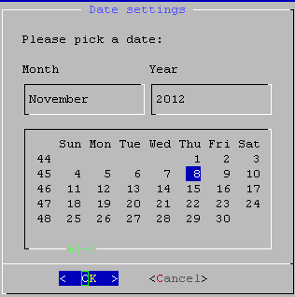
Select today's Date and press the Enter key to move on to setting the Time.
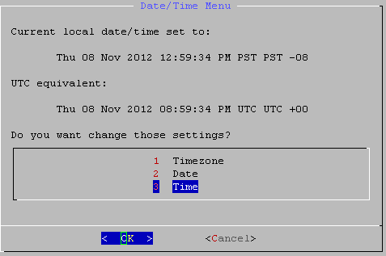

If the Time setting is incorrect, highlight the Time menu item and press the Enter key. If Timezone, Date and Time are correct, press the Right Arrow key to select <Cancel> and press the Enter key.
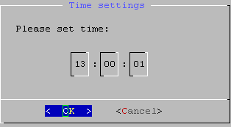
Click on the Hour Minute and Second windows to change the 24 hour time setting and then press the Enter key to select this time and return to the Main Menu.

The Appliance Admin User Interface also provides two additional capabilities:

- Reboot the Appliance
- Network Diagnostics

To Reboot the Appliance
From the Main Menu, highlight the Reboot menu item
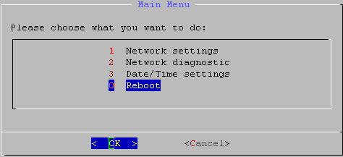
Press the Enter key
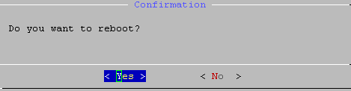
Press the Enter key to Reboot the Appliance or press the Right Arrow key to Select <No > to return to the Main Menu. This session will disappear if < Yes > is selected.

Network Diagnostics
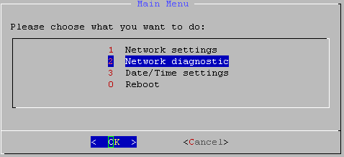
Use the Network Diagnostics menu to display the Appliance's routing tables; Display the Appliance's network configuration details; Ping an IP address from the Appliance; Run a Traceroute from the Appliance to an IP Address.
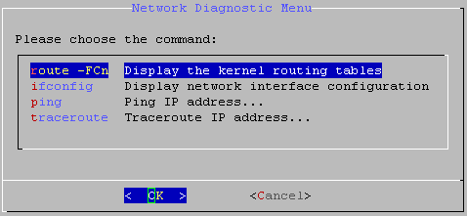
Highlight the desired diagnostic feature and press the Enter key. The first two items (Display routing tables and network configuration are view only interfaces. Ping and Traceroute take an IP address as input.

K) Troubleshooting Tips

Installation
The Load DynamiX TDE is dependent on the .NET framework version 3.5.1. Please be sure that version 3.5.1 is present on the Load DynamiX Management Workstation.

The HTTP protocol is used to communicate between the Load DynamiX Workstation and Appliance. The Load DynamiX Workstation must be able to send HTTP packets to the Load DynamiX Appliance.

Project Execution

Product Features
There are a number of capabilities that the Load DynamiX product provides that are intended to help determine if the desired results are achieved.

PCAP (Tracing Parameters) - packet capture and review is often one of the easiest ways to find issues with test programs including items such as:
Initiator and Target information
SCSI Protocol specific information (e.g. meta data (ex: Report LUNs) and Read and Write commands, return codes)
Event order (in what sequence do different Actions take place)

NOTE: Tracing Parameters are not a performance tool. Using Tracing Parameters to capture PCAP data will reduce performance in the Load DynamiX Client and Server software.

Results Folder - the results folder contains the statistics and log files that are captured during the execution of a Load DynamiX test Project.
Statistics - statistics are captured real time and may be observed by opening the Results Folder during a test run and selecting the statistic that is interesting.
For example,
FC SCSI Commands – view counts of the number of commands of a given type executed
Load Status - to see how the various Scenarios launched by the test are doing, etc.

While these statistics can be used for real time evaluation of the progress of a test, they are also excellent troubleshooting tools.

Client and Server Port log files - at the end of a test run, the Load DynamiX appliance sends a log file to the TDE containing execution details for the test. There is a log file for each virtual port in the test and this log file can be immensely helpful in determining the cause of test failures. Network statistics are captured in Client and Server log files for debugging purposes. These statistics can be used to debug issues at the lowest levels of the communications process.

